Ideation Phase

Define the Problem Statements

|  |  |
| --- | --- |
| Date | 28 June 2025 |
| Team ID | LTVIP2025TMID37691 |
| Project Name | Sustainable Smart City Assistant using IBM Granite LLM |
| Maximum Marks | 2 Marks |

Customer Problem Statement :

|  |  |  |  |  |  |
| --- | --- | --- | --- | --- | --- |
| Problem  Statement (PS) | I am  (Customer) | I’m trying to | But | Because | Which makes me feel |
| PS-1 | city resident. | to understand how my city is performing in terms of sustainability and  how I can | I can’t easily access realtime data or interpret  complex policy | the current systems are fragmented, technical, and not citizenfriendly. | disconnected and unsure about how to take meaningful action. |

Urban residents and city administrators struggle to access real-time, actionable insights about sustainability metrics such as energy usage, pollution levels, and policy updates. Existing systems are fragmented, non-intuitive, and lack intelligent support for decisionmaking or citizen engagement. There is a need for a unified, AI-powered assistant that can simplify complex data, provide personalized eco-advice, and foster transparent communication between citizens and city services

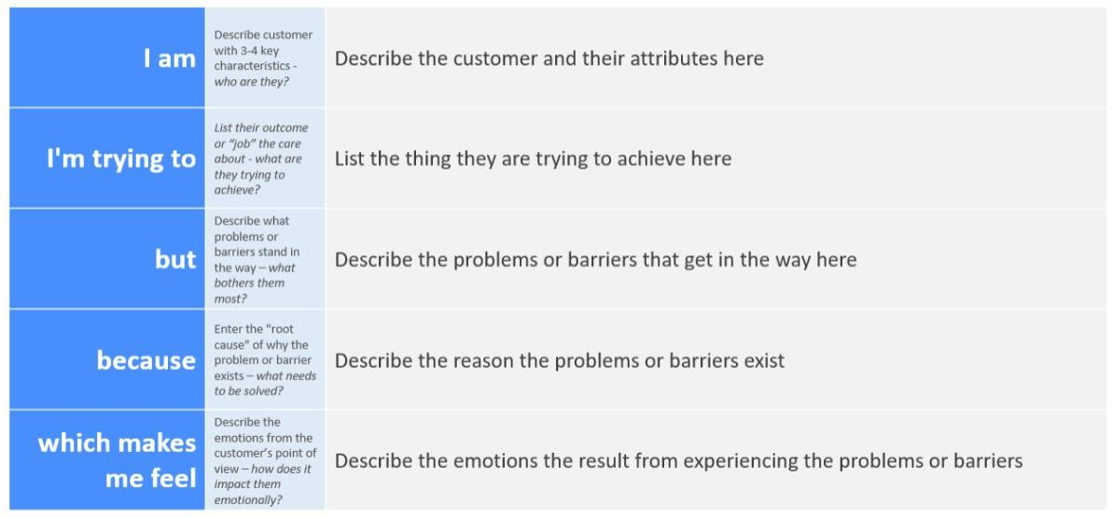

Example:

|  |  |  |  |  |  |
| --- | --- | --- | --- | --- | --- |
|  |  | contribute. | documents. |  |  |
| PS-2 | city administrator. | to monitor sustainability KPIs and respond to citizen feedback efficiently. | lack an integrated platform that  combines  AI insights with realtime urban data. | existing tools are siloed and don’t support intelligent automation. | makes me feel overwhelmed and unable to make timely, informed decisions. |